# 实验：缓存数据库redis主从配置

**缓存数据库，保存在内存中**

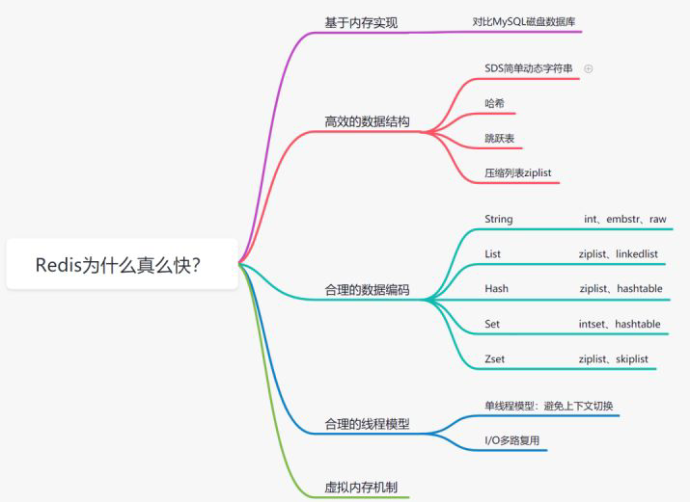

**实验环境：**

**192.168.7.10 master**

**192.168.7.11 slave**

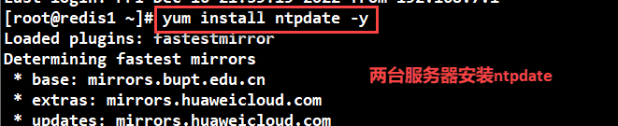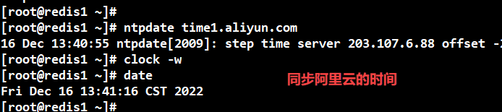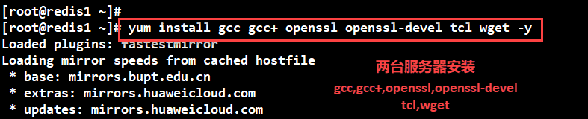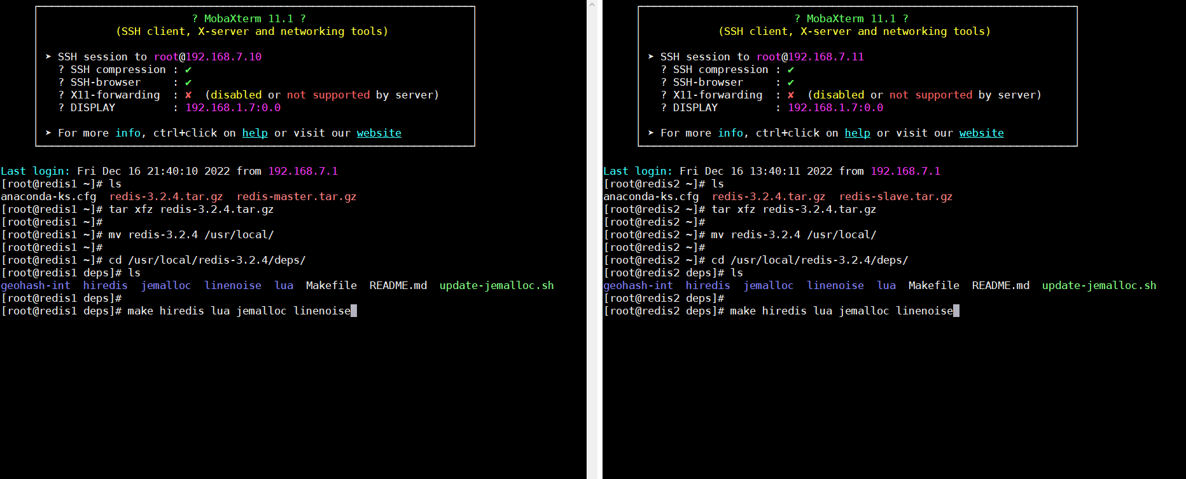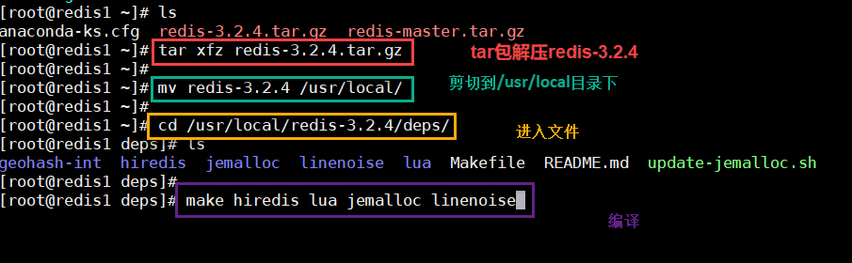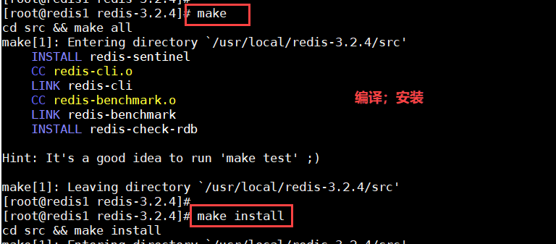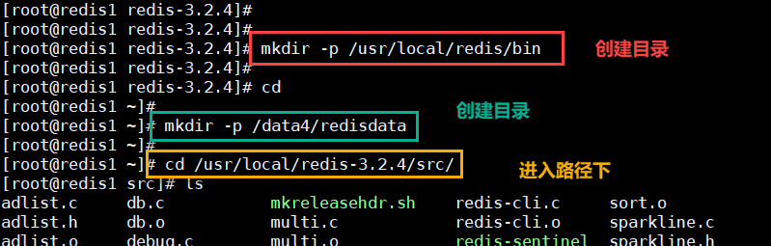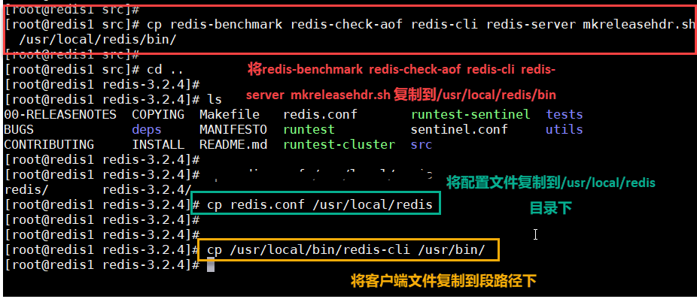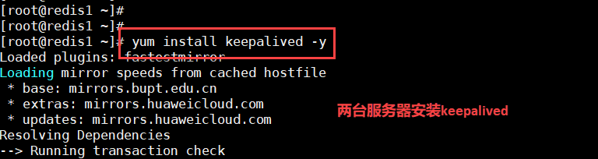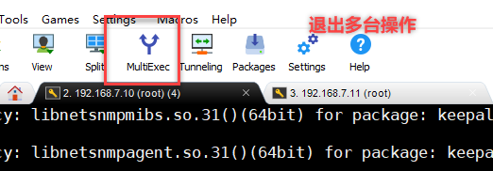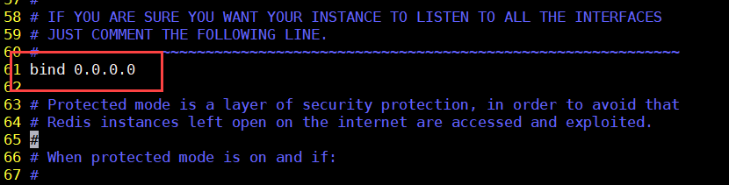

**daemonize:yes**: **redis采用的是单进程多线程的模式。当redis.conf中选项daemonize设置成yes时，代表开启守护进程模式。在该模式下，redis会在后台运行，并将进程pid号写入至redis.conf选项pidfile设置的文件中，此时redis将一直运行，除非手动kill该进程。**

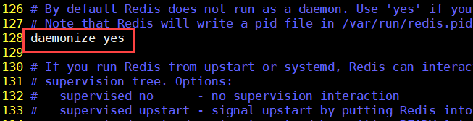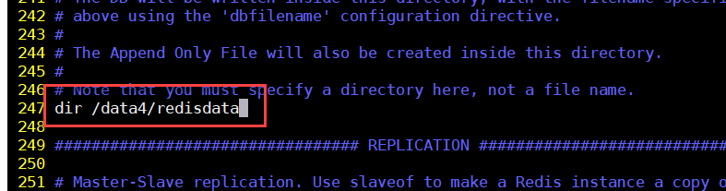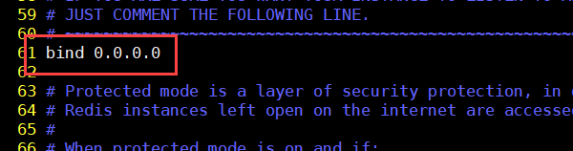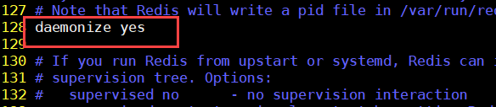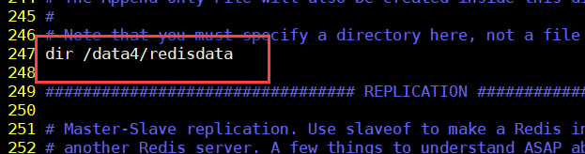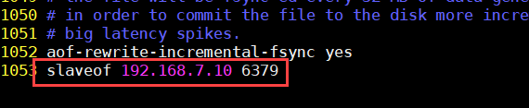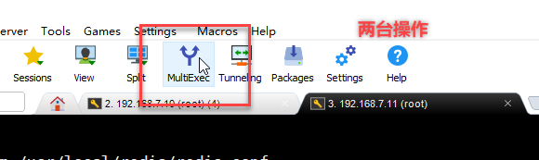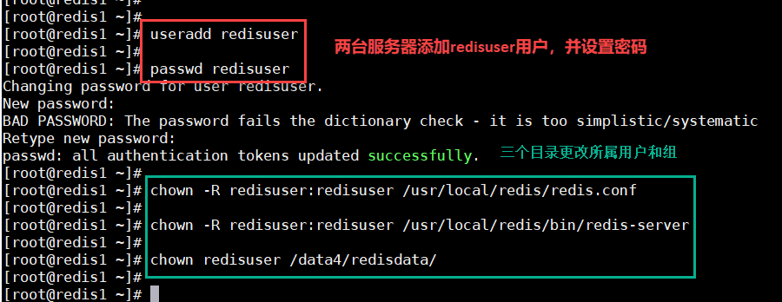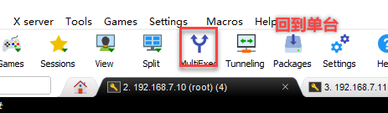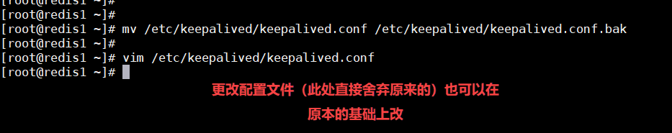

**! Configuration File for keepalived**

**global_defs {**

**router_id LVS_DEVEL**

**}**

**vrrp_script chk_redis {**

**script "/etc/keepalived/scripts/redis_check.sh"**

**weight -20**

**interval 2**

**}**

**vrrp_instance VI_1 {**

**state MASTER**

**interface ens33**

**virtual_router_id 51**

**priority 100**

**advert_int 1**

**authentication {**

**auth_type PASS**

**auth_pass 1111**

**}**

**virtual_ipaddress {**

**192.168.7.254**

**}**

**track_script {**

**chk_redis**

**}**

**notify_master /etc/keepalived/scripts/redis_master.sh**

**notify_backup /etc/keepalived/scripts/redis_backup.sh**

**notify_fault /etc/keepalived/scripts/redis_fault.sh**

**notify_stop /etc/keepalived/scripts/redis_stop.sh**

**}**

